Policies_Verifying Agency Billed Policy_Instance43_29-May-2018_02-52-47_AM_ValidationofAgencyBilledPolicy.png

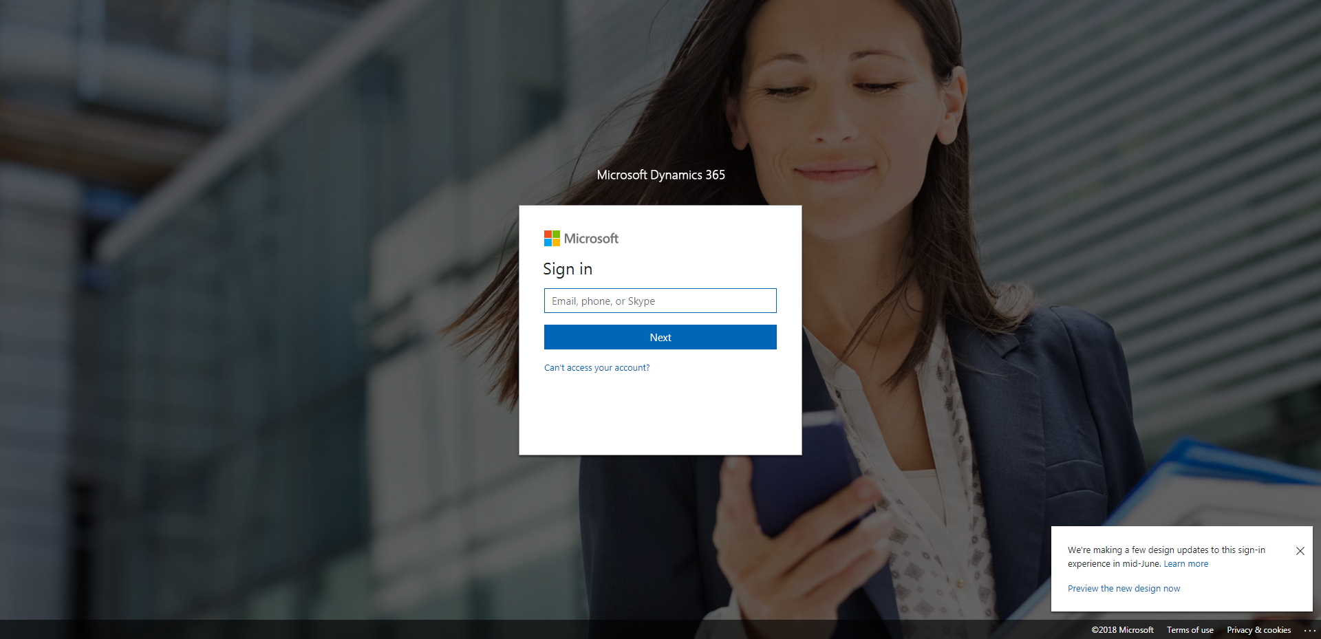

Policies_Verifying Agency Billed Policy_Instance43_29-May-2018_02-52-46_AM_SingleSignOn.png

